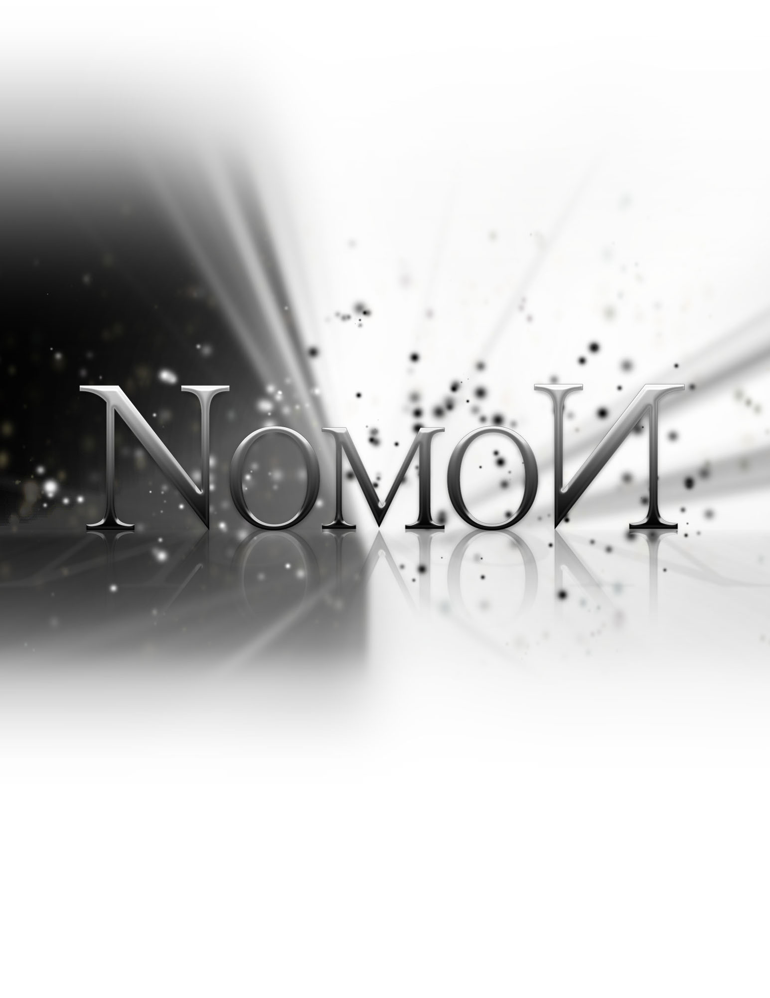
Status Report

Friday, October 28, 2011

Status Report

The List of Tasks to be done by this period:
  - Puzzle Concepts Finalized - October 17th 2011
  - Level Design Complete - October 26th 2011

Tasks underway:

Concept Art - 70% Complete
Worked on by Sarah (20%), Shaughn (30%), Adam (10%), Tom (10%)

Art Research - 90% Complete
Sarah (50%), Shaughn (40%)

Research into the unreal engine - 100% Complete
Tom (50%), Nik (10%), Adam (10%), Sarah (5%), Shaughn (25%)

Platformer tutorial - 70% Complete
Nik (30%), Adam (30%), Tom (10%)

Web Design - 70% Complete
Shaughn (50%), Sarah (20%)

Modelling - 30% Complete
Tom (5%), Sarah (10%), Shaughn (10%), Adam (5%)

Rigging - 100% Complete
Sarah (100%)

We will need to implement the following functionality:
- Object carrying mechanic: Certain objects need to be able to be carried. Developers need to simply code in a few triggers and have a supporting character animation to enable this.
- Enemy as a platform: When enemies are “inactive” they can be used as platforms. This will simply have to be an internal switch of some sort.

We also need to build assets for the levels, finish puzzle and level design and implement all the levels to get ready for alpha testing.

List of Tasks Accomplished by their appropriate date:

- Design for level 1
- Basic puzzles
- Character model & rig
- Light mechanics solved (light/shadow detection, light switching, moving lights)

List of delivered results of the tasks (files, etc)

- Maya Binary – character model & rig, other level assets
- UDK Files – level 1 skeleton
- Images – level 1 design, character render

Challenges and problems faced

Insufficient Time Allotted
Too much time is being allocated to individual projects and other courses at this point. When time was spent on Nomon, it was mostly used by the whole team to gain a better understanding of the engine, rather than creating game components.

Solution: allocate more segregated work time for each project, rather than letting imminent deadlines dictate the workflow.

